Bird Notes
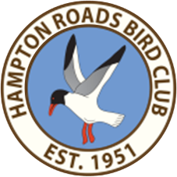
Newsletter of the

Hampton Roads Bird Club (HRBC)
www.hamptonroadsbirdclub.org and on Facebook

Vol. 72, No. 5 May-June 2024

Thursday, May 9 Meeting 6:30 PM Social 7:00 PM Program
Sandy Bottom Nature Park

Annual Election of Officers

Candidates needed for Hospitality and Publicity.

Video: "America's Arctic –
Teshekpuk Wetlands"

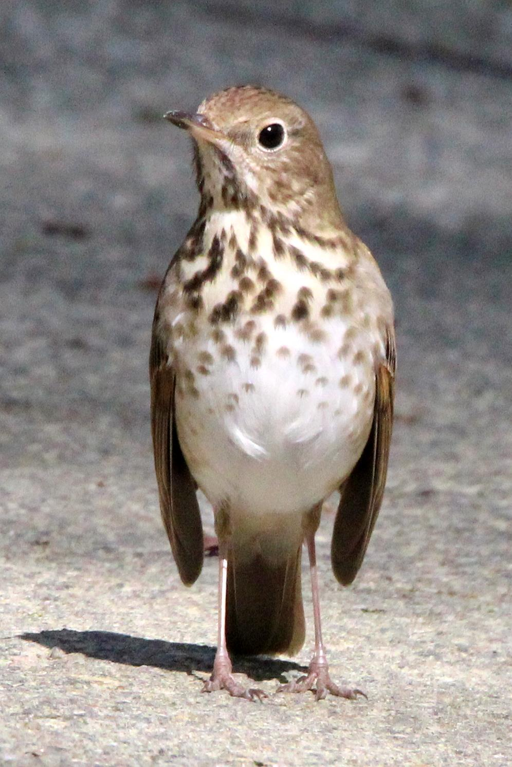
Hermit Thrush by Dianne Snyder NN Park walk on Sunday, April 7, 2024

Saturday, June 8 End of Year Picnic Noon Arrival 12:30 PM Meal
Sandy Bottom Nature Park

Another club year is coming to a close and it is time to plan for our last function…the end of the year picnic and installation of next year’s officers.
This year our picnic will again be at the Parker Pavilion at Sandy Bottom Nature Park and will be held on Saturday, June 8, 2024. This shelter is located near the canoe launch and directly across the
street from the outside bathrooms nearest to the Hampton Center Parkway entrance. As last year, we will not be grilling, but will be doing a cover dish. Please choose between an appetizer,
salad, main dish or dessert to serve at least 8 people. The club will provide paper products, ice, tea and water. Last year this provided a good variety of food and a great opportunity to sample something
different. There will be a sign-up sheet at the May 9 meeting or you can call, text or email me to let me know if you plan to attend and the number coming (spouse, family etc.), and what you plan to
bring. I will keep a list to avoid having multiples of the same dish. Jane Frigo birderjane@gmail.com
home 757-873-0721, cell 757-776-7925

________________________________

HRBC Outdoors

Regular Bird Walks in Newport News Park
7:00 AM on 1st and 3rd Sundays of all 12 months, unless the city schedules a special mass event.
Meet at big parking lot behind Ranger Station.
Leader: Jane Frigo birderjane@gmail.com home 757-873-0721, cell 757-776-7925

HRBC Spring Bird Count
Saturday, May 4, 2024 Coordinator: Bill Boeh phrogdolph@gmail.com
757-951-7959.

Greensprings / Powhatan Creek Trails
Saturday, May 11, 2024
Leader: James Abbott jaa3469@gmail.com 757-320-9191 (text or phone)

End of Year Picnic
Noon, Saturday, June 8, 2024
Leader: Jane Frigo birderjane@gmail.com home 757-873-0721, cell 757-776-7925

Jane Frigo sends a special “Thank you” to those who have brought snacks to our meetings and Sunday walks.

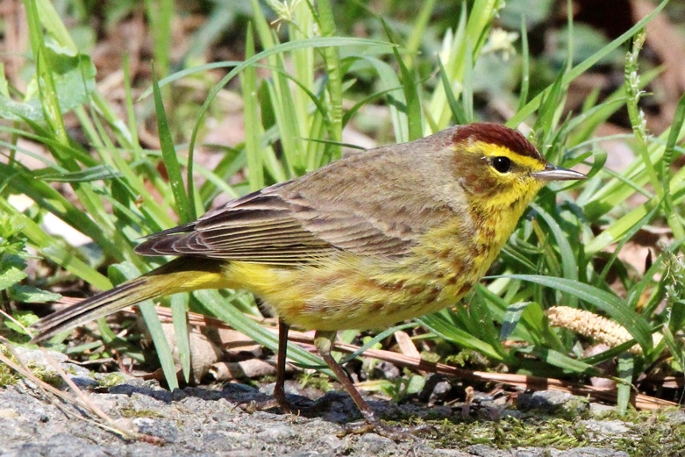
Palm Warbler by Dianne Snyder NN Park walk on Sunday, April 7, 2024

HRBC 2024 Spring Bird Count
Saturday May 4, 2024

By Bill Boeh

The HRBC has been conducting the Spring Bird Count (SBC) since 1995. Please join us in being
part of this citizen science effort to support bird conservation. It’s great fun and a great way to
help conserve the birds--and for new members, a great way to be introduced to some of the best birding sites in our region. The count will be conducted in the same manner as the Christmas Bird Count, within the Newport News circle. The circle is divided into 13 sectors on the lower Peninsula; each
sector will have its own team of observers. The typical count spans most of the day, but some counts
only go for a few hours. Don’t hesitate to participate because you don’t feel you’re proficient enough at identifying birds - sector counts are led by our more experienced birders. You can contribute by adding more eyes and ears to help detect the birds for identification (and counting). You’ll be building your identification skills as well. If you can’t participate in a field count, feeder-watching is another way you can support this effort. Please let me know if you are interested in participating by
email or phone/text at phrogdolph@gmail.com
757-951-7959.

Bluebird Nestbox Trail at Newport News Golf Course
By Bill Boeh
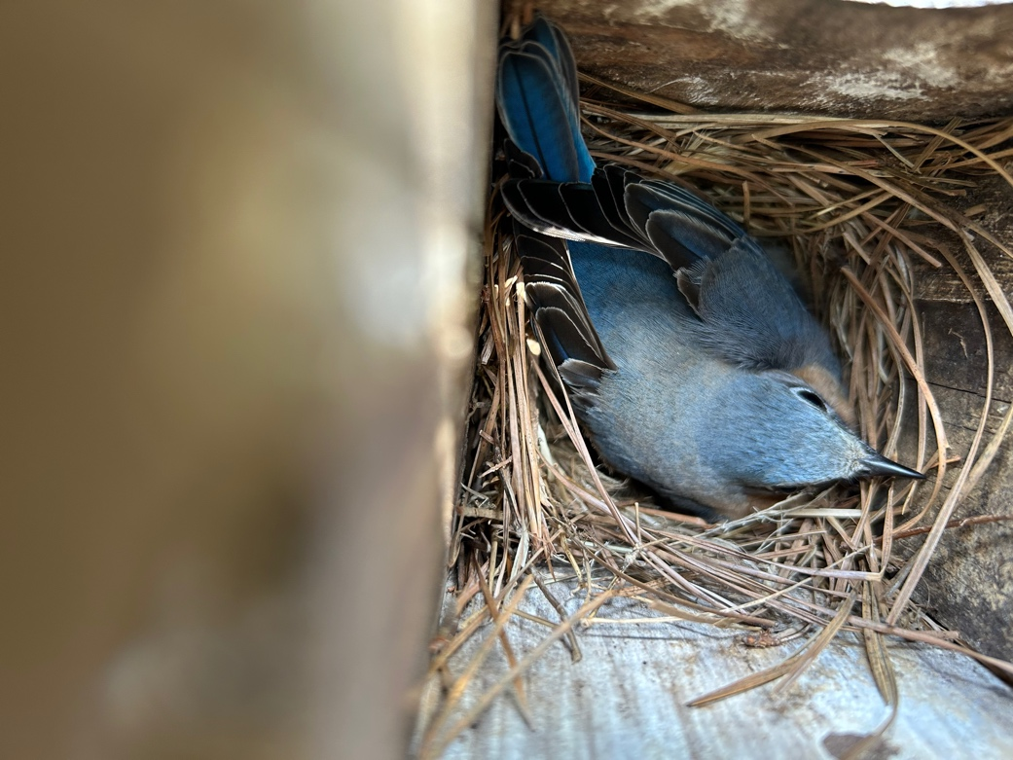Female Eastern Bluebird on April 25, 2024

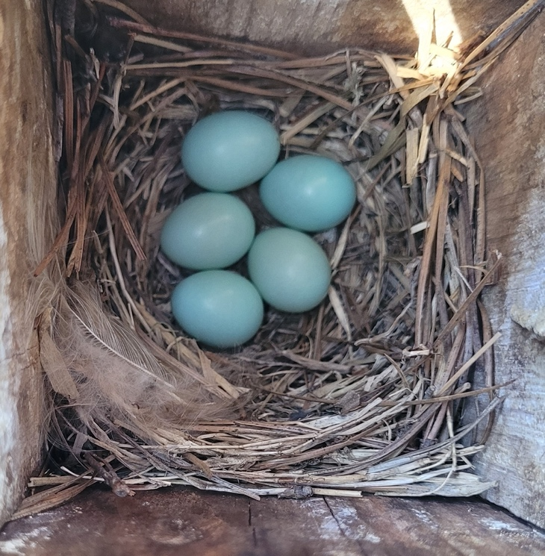Nestbox C03WR on April 18, 2024
As of April 19, the Newport News Golf Club (NNGC) Bluebird trail status is as follows:
- Nesting summary (includes failed attempts):
  - 30 nesting attempts so far out of the 52 boxes we’re monitoring.
    - Currently active attempts:
      - Eastern Bluebird (EABL): 24 attempts; 21 completed nests, 82 eggs (2 lost due to suspected snake predation)
      - Carolina Chickadee (CACH): 3 attempts: 2 completed nests, 11 eggs
- Training: Training is moving along well. We currently have 22 total volunteers, with 15 fully qualified, listed below (trainers are indicated by an asterisk*):
  - John Adair*
  - Bill Boeh*
  - Robert Drees
  - Helene Drees
  - Ellis Maxey*
  - Wendy Maxey*
  - Pete Peterman*
  - Cindy Schulz
  - Olivia Schulz
  - David Singletary
  - C. L. Tanner*
  - Sue Tominaga
  - Barb Waring
  - Tina White
  - David Youker*

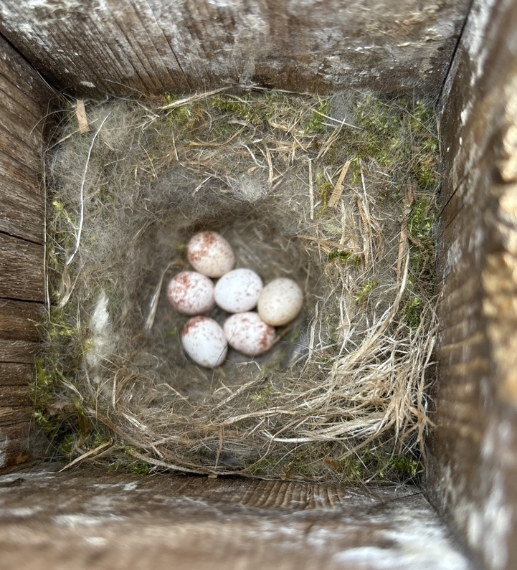
Nestbox C06BL4 on April 4, 2024

Progress on the “Tree of Life” for Birds

By Pete Peterman

Published in the journal Nature, this genome study is the product of nearly a decade of research as part of the Bird 10,000 Genomes Project. It included species from every major group, or family, of birds and included 363 genomes. It was done by researchers at the University of Copenhagen, University of California San Diego, and Zhejiang University in China.

The study, which included nearly 200 fossils, showed that most modern birds first appeared within 5 million years after the extinction of the dinosaurs and that all living birds share an ancestor that lived over 90 million years ago.

The bird family tree has three major branches. The first branch contains the tinamous and ratites which includes flightless birds such as the emu, kiwi and ostrich. The second branch holds the landfowl and waterfowl –chickens, ducks and so on. All other birds sit on the third branch, known as the Neoaves.
The Neoaves include ten groups of birds; the “Magnificent Seven” are landbirds, waterbirds, tropicbirds, cuckoos, nightjars, doves and flamingoes; the other three groups of Neoaves are known as the “orphans” and include shorebirds, cranes, and hoatzin.

The relationships among these ten groups have been difficult to obtain but this study shows that a resolution is within reach.

The study revealed a new grouping of birds that have been named “Elementaves”. This group includes hummingbirds, shorebirds, cranes, penguins and pelicans

The study confirmed a close relationship between the passerines (songbirds and relatives) and parrots. Songbirds make up nearly 50% of all bird species. They had their beginnings in Australia about 50 million years ago, and then spread across the globe to become the most successful group of birds.

Even with this huge amount of genome data, one branch of the bird family tree remains a mystery. The analysis could not confidently determine the relationship of one of the orphans, the hoatzin. Found in South America, the hoatzin is a highly distinctive bird and the sole survivor of its lineage.

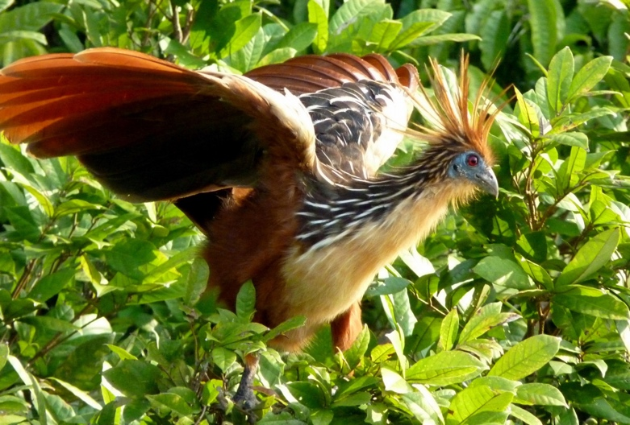Hoatzin by Kate of UK (snatched from Wikipedia by Pete)

Winter Photo Contest Winners

By Michael Meyer

March 2024

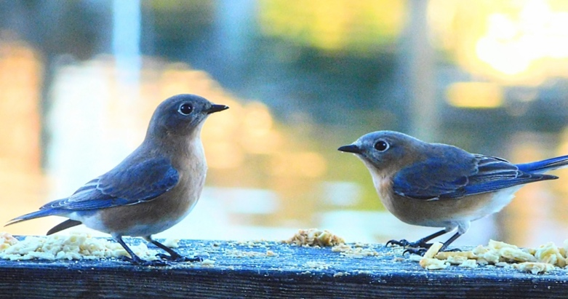
Eastern Bluebirds
Gold by Lynn Chandler

Lynn: “I feed the birds this winter a lot on the railing of my deck as well as in the cage and dish on the table. The railing was what seemed to be their favorite. The Blue Birds are still coming and eating a ton of worms. Have already seem them feeding a fledgling.”

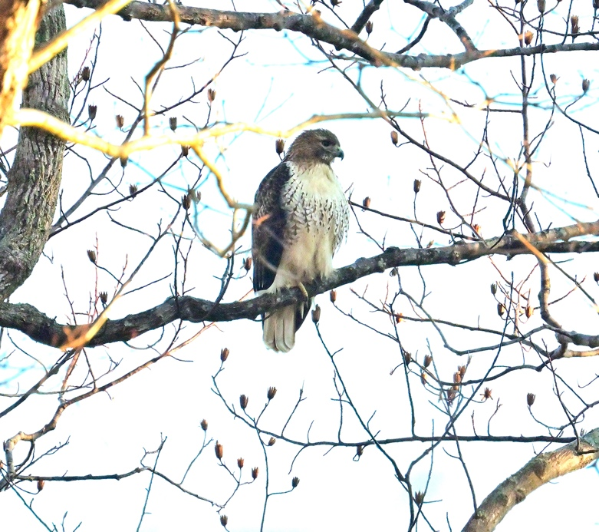
Red-tailed Hawk
Silver by Pete Peterman

Pete: “Here is the info on the photos. All were taken with the Nikon Z-50 with a Nikon 200-400 mm lens and a 1.4x extender to obtain a 560mm reach. The
Red-tailed Hawk was taken at NN Park on Feb 2 on our regular bird walks led by Jane Frigo and was taken at 1/1000 of a second at f 13 and an ISO of
1100.”

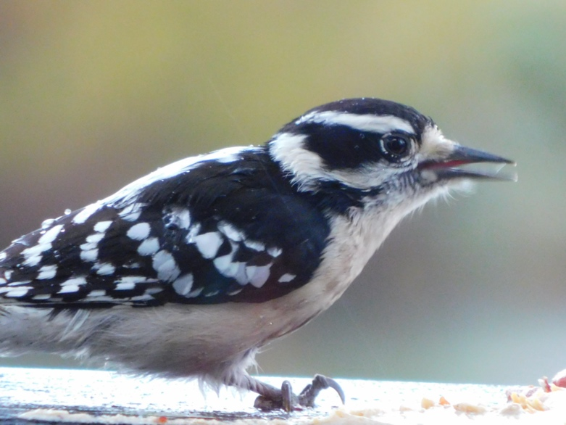
Downy Woodpecker with no left leg
Bronze by Lynn Chandler

Lynn: “The Downy is called "Lefty" because she does not have a left leg at all. She is also still coming to the suet and eating well.”

April 2024

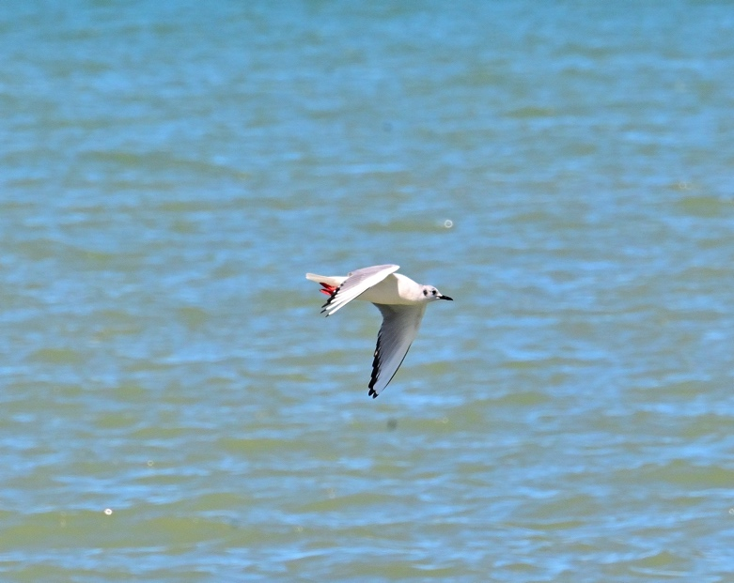
Bonaparte’s Gull
Gold by Pete Peterman

Pete: “The Bonaparte's Gull was taken at Geneva State Park in Ohio on Apr 7 where I was camped for the total solar eclipse. There were a group of them flying and then landing on the water to gulp down fish from a school that had come close to shore. I used 1/1000 of a second at f 16 and an ISO of 800.”

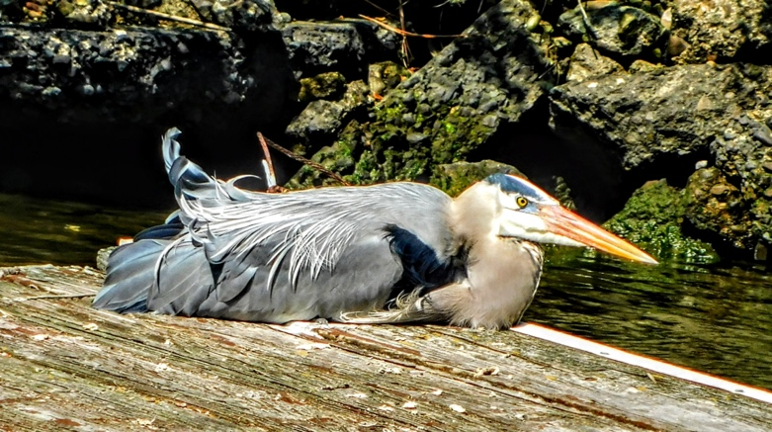
Great Blue Heron lying down
Silver by Lynn Chandler

Lynn: “Seeing the Great Blue Heron laying down was a shock the first time! I've lived here 26 years now and this Feb./Mar. is the first time ever I have witnessed any G.B. Heron laying down. The first time I was so shocked and busy that I forgot to take a picture. This second time in late March at 1:30pm I did not let the opportunity get by me!”

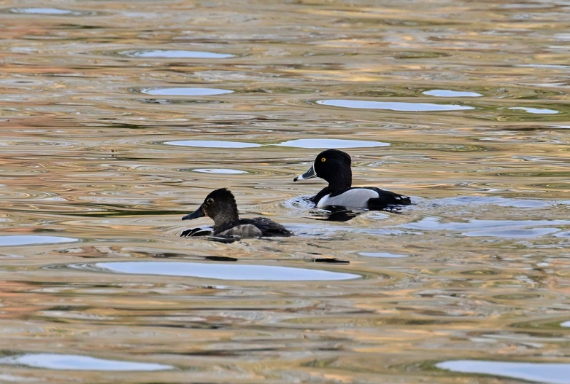
Ring-necked Ducks
Bronze by Pete Peterman

Pete: “ The Ring-neck Ducks were also taken at NN Park on Mar 17 on our regular bird walks and was taken at 1/1000 of a second at f 13 and an ISO of 1600. I found the pair on the other side of the bridge from the Ranger Station parking lot.”

Here are the contest rules:

1. A member may submit up to 2 photos each month taken in the last 60 days.
2. Please name each file with the photographer and the bird’s name (i.e., ShawnDash_Osprey).
3. Submit to Michael Meyer (michael.meyer@cnu.edu) by the 10th of each month.
4. Winners will be contacted by the newsletter editor to provide either a short writeup or a brief phone interview from which a narrative may be composed.

Reports for Sunday Walks in Newport News Park and Field Trips
By Bill Boeh
Links to eBird reports for March and April 2024 events are at the top of the column on the right. Each link takes you to the text summary of a HRBC “1st and 3rd” Sunday walk in Newport News Park or field trip; and to the associated eBird checklist(s). Checklists often have photos.

Date | Location | Report Link
Mar. 2 | NN Park | https://ebird.org/tripreport/207921
Mar. 17 | NN Park | https://ebird.org/tripreport/207922
Apr. 7 | NN Park | https://ebird.org/tripreport/217686
Apr. 21 | NN Park | https://ebird.org/tripreport/217687
Apr. 21 | Dsml Swmp | https://ebird.org/tripreport/217687

Research on the Amazing Spatial Memory of the Mountain Chickadee
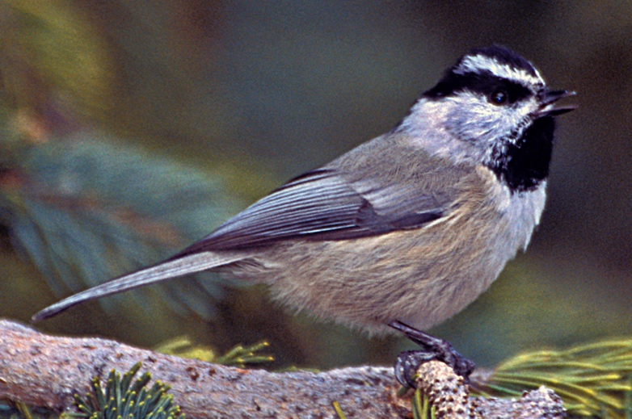The Mountain Chickadee of Wikipedia
The white eyebrows of the Mountain Chickadee help to distinguish it from other chickadees. But somewhere between those eyebrows is a tiny brain with a super spatial memory; the bird can recall tens of thousands of locations where it has cached food to survive the winter. The popular ScienceDaily website informs of research from the University of Colorado Boulder (Prof. Scott Taylor) and the University of Nevada Reno (Prof. Vladimir Pravosudov):
https://www.sciencedaily.com/releases/2024/04/240417131136.htm
Birds were tested with a complex array of feeders, each of which would give access only to particular individuals, depending on a radio signal keyed to the foot band. Birds had to learn and recall the feeders that worked for them, allowing spatial learning and memory to be rated. The entire genomes of 162 birds were sequenced. 97 genes were found to be associated with the ratings. “Birds with specific genetic variants at these genes made fewer wrong attempts before landing on their designated feeders.” Next the feeders were scrambled. Curiously, birds with better long-term memory succeeded in creating new memory more slowly.

President Shawn Dash drshawntdash@gmail.com 915-491-6227
Vice President Mark Sopko mgsopko@gmail.com 804-815-2897
Secretary William Boeh phrogdolph@gmail.com 757-951-7959
Treasurer John Adair adairjj@gmail.com 757-224-8920
Board (7/21-6/24) Katrina Dash kmdash4@gmail.com 915-471-1287
Board (7/22-6/25) Michael Meyer michael.meyer@cnu.edu 757-303-4790
Board (7/23-6/26) Pete Peterman. rwpeterman@verizon.net 757-766-8658
Board (former Pres.) Dave Youker youkerd@aol.com 757-344-9385
Field Trip Coordinator James Abbott jaa3469@gmail.com 757-320-9191
Web Editor Wendy Maxey emaxey@verizon.net 757-483-3003
Web Editor Ellis Maxey emaxey@verizon.net 757-483-3003
Hospitality Jane Frigo birderjane@gmail.com 757-776-7925
Newsletter Editor Thomas Charlock tomcharlock@gmail.com 757-746-9190
Membership Gwen Harris gwenkharris65@gmail.com 757-898-8649

TO JOIN OR RENEW. If you would like to join the Hampton Roads Bird Club or renew your membership, there are several convenient ways to do so. Dues remain at $15.00 for individuals and $20.00 for families. New members, and anyone whose information has changed, please complete the form below and send to John Adair, HRBC Treasurer. Submit your application and payment as follows:
1) Mail to: John Adair, 109 Nansemond Turn, Yorktown, VA 23693, adairjj@gmail.com.
2) Drop off at: Wild Wings Nature Store, Glendale Shopping Center in Newport News.
3) Drop off at: Wild Birds Unlimited, Kiln Creek Parkway in Yorktown.
4) Pay by PayPal or credit card at: https://www.hamptonroadsbirdclub.org/membership.

Hampton Roads Bird Club – Membership Form

New Member (F/I) ____ Renewal ____ Date: _________________

Name(s): __________________________________________________________________

Address: __________________________________________________________________

City, State, Zip: _____________________________________________________________

Phone: H: ___________________ C: _____________________ W: ___________________

Email(s): ____________________________________________________________________

Only check this box if you need the newsletter delivered via the postal system;
HRBC is trying to save trees and reduce club expenses by using email.

=============================================

Editor (T. Charlock)
Hampton Roads Bird Club
22 Executive Drive
Newport News, Virginia 23606-2225
